**DYNAMIC TRAFFIC MANAGEMENT SYSTEM**

**A PROJECT REPORT**

**Submitted By**

**RICHARD NICHOLES M (310121104085)**

**SANJAY RAHUL P (310121104088)**

**STEPHEN KOVIL PILLAI A (310121104101)**

***In Partial Fulfillment for The Award of The Degree Of***

**BACHELOR OF ENGINEERING**

**in**

**COMPUTER SCIENCE AND ENGINEERING**

**ANAND INSTITUTE OF HIGHER TECHNOLOGY**



**ANNA UNIVERSITY: CHENNAI 600 025**

**NOVEMBER 2024**

**ANAND INSTITUTE OF HIGHER TECHNOLOGY**

**(An Autonomous Institution)**

**DEPARTMENT OF COMPUTER SCIENCE AND ENGINEERING**

**BONAFIDE CERTIFICATE**

Certified that this project **“DYNAMIC TRAFFIC MANAGEMENT SYSTEM”** is the bonafide work of **RICHARD NICHOLES M (310121104085) SANJAY RAHUL P (310121104088)** and **STEPHEN KOVIL PILLAI A (310121104101)** who carried out the project work under my supervision.

**SIGNATURE SIGNATURE**

**Mrs. M.Maheswari, M.E.,(Ph.D). Mrs. R. Pratheeba, M.E.,**

**HEAD OF THE DEPARTMENT, ASSISTANT PROFESSOR,**

Department of Computer Science Department of Computer Science

and Engineering, and Engineering,

Anand Institute of Higher Technology, Anand Institute of Higher Technology,

Kazhipattur, Chennai-603103 Kazhipattur, Chennai-603103

Submitted for University Examination held on -----------------------

**INTERNAL EXAMINER EXTERNAL EXAMINER**

**ACKNOWLEDGEMENT**

First and foremost, we thank the almighty, for showering his abundant blessings on us to successfully complete the project. Our sincere thanks to, our beloved “**Kalvivallal” Late Thiru T. Kalasalingam, B.Com., Founder** for his blessings towards us.

Our sincere thanks and gratitude to our **SevaRatna Dr. K. Sridharan, M.Com., MBA., M.Phil., Ph.D., Chairman, Dr. S. Arivazhagi, M.B.B.S., Secretary** for giving us the necessary support during the project work. We convey our thanks to our **Dr.K. Karnavel, M.E., Ph.D., Principal** for his support towards the successful completion of this project.

We wish to thank our **Head of the Department Mrs. M. Maheswari, M.E.,(Ph.D),** our **Project Coordinator Mrs. R. Elakiya** and our **Guide** **Mrs. R. Pratheeba M.E., Assistant Professor** for the co-ordination and better guidance and constant encouragement in completing in this project.

We also thank all the **Staff members** of the Department of Computer Science and Engineering for their commendable support and encouragement to go ahead with the project in reaching perfection.

Last but not the least our sincere thanks to all our parents and friends for their continuous support and encouragement in the successful completion of our project.

#### ABSTRACT

Traffic congestion is a major urban challenge, leading to delays, fuel wastage, and increased emissions. To address this issue, our project presents a Dynamic Traffic Management System powered by IoT and Machine Learning techniques. The system integrates live surveillance with intelligent decision-making to optimize traffic flow and minimize congestion. The system simultaneously identifies vehicles and pedestrians. A dual-camera setup allows one camera to monitor vehicle density at intersections, while the other detects pedestrian movement. By analyzing real-time data, the system dynamically predicts and adjusts traffic light timings based on vehicle counts, pedestrian crossings, and congestion levels. This solution operates autonomously under live surveillance, making it adaptable to various traffic conditions without human intervention. With a focus on scalability, it leverages IoT for seamless data communication and management, ensuring reliable performance even in complex urban environments. The ultimate goal of this system is to eliminate traffic bottlenecks by implementing data-driven signal control, thereby improving urban mobility, reducing environmental impact, and enhancing public safety. By combining state-of-the-art object detection and machine learning with IoT integration, this project introduces a robust, intelligent approach to traffic management that paves the way for smarter cities.

**TABLE OF CONTENTS**

|  |  |  |  |  |
| --- | --- | --- | --- | --- |
| **CHAPTER** | **TITLE** | | **PAGE NO** | |
|  | **ABSTRACT** | **iv** | |
|  | **LIST OF FIGURES** | **vii** | |
|  | **LIST OF ABBREVATIONS** | **viii** | |
|  | **LIST OF TABLES** | **ix** | |
| **1** | **INTRODUCTION** | | **10** | |
|  | 1.1 OBJECTIVE | | 11 | |
|  | 1.2 SCOPE | | 11 | |
| **2** | **LITERATURE SURVEY** | | **12** | |
| **3** | **ANALYSIS** | | **17** | |
|  | 3.1 SYSTEM ANALYSIS | | 17 | |
|  | 3.2 REQUIREMENT ANALYSIS | | 19 | |
| **4** | **DESIGN** | | **21** | |
|  | 4.1 OVERALL DESIGN | | 21 | |
|  | 4.2 UML DIAGRAMS | | 22 | |
|  | 4.2.1 Work Flow Diagram | | 22 | |
|  | 4.2.2 Use Case Diagram | | 23 | |
|  | 4.2.3 Class Diagram | | 24 | |
|  | 4.2.4 Activity Diagram | | 25 | |
|  | 4.2.5 Sequence Diagram | | 26 | |
| **5** | **IMPLEMENTATION** | | **27** | |
|  | 5.1 MODULES | | 27 | |
|  | 5.2 MODULE DESCRIPTION | | 27 | |
| **6** | **TESTING** | | **29** | |
|  | 6.1 TESTING AND VALIDATION | | 29 | |
|  | 6.1.1 Unit Testing | | 29 | |
|  | 6.1.2 Functional Testing | | 30 | |
|  | 6.1.3 System Testing | | 31 | |

* + 1. Acceptance Testing 32
  1. BUILD THE TEST PLAN 33

1. **RESULTS AND DISCUSSION** **37**
2. **USER MANUAL** **40**
3. **CONCLUSION** **42**
4. **FUTURE ENHANCEMENT** **43**

**APPENDICES**

APPENDIX I : BASE PAPER

APPENDIX II : SCREENSHOTS

APPENDIX III : INTERNSHIP CERTIFICATES

**REFERENCES**

**LIST OF FIGURES**

|  |  |  |
| --- | --- | --- |
| **FIGURE NO** | **FIGURE DESCRIPTION** | **PAGE NO** |
| 4.1 | Proposed System Architecture | 21 |
| 4.2 | Work Flow Diagram | 22 |
| 4.3 | Use Case Diagram | 23 |
| 4.4 | Class Diagram | 24 |
| 4.5 | Activity Diagram | 25 |
| 4.6 | Sequence Diagram | 26 |

**LIST OF ABBREVATIONS**

**SYMBOLS ABBREVATIONS**

**YOLO** You Only Look Once

**CV** Computer Vision

**GPU** Graphical Processing Unit

**LIST OF TABLES**

|  |  |  |
| --- | --- | --- |
| **TABLE NO** | **TABLE NAME** | **PAGE NO** |
| 6.1 | Test Case Design | 35 |
| 6.2 | Test Case Log | 36 |

**CHAPTER 1 INTRODUCTION**

Urban traffic congestion is a global issue, causing delays, fuel wastage, and pollution. Conventional traffic systems with static signal timings fail to address real-time variations, leading to inefficiency, especially during peak hours. To overcome these challenges, our project introduces a Dynamic Traffic Management System that utilizes live video surveillance and machine learning to optimize traffic flow efficiently.

The system relies entirely on video inputs from cameras placed at intersections, eliminating the need for physical sensors. One camera monitors vehicle density, while the other tracks pedestrian crossings, enabling real-time detection and counting. This dual-camera setup provides a comprehensive traffic overview, ensuring effective management.

By leveraging machine learning and predefined rules, the system dynamically adjusts signal timings based on traffic conditions. It predicts congestion levels and ensures optimal traffic flow, prioritizing safety for both commuters and pedestrians. This approach eliminates the need for costly additional hardware, making it scalable, efficient, and adaptive.

The project's goal is to create a cost-effective, intelligent solution to reduce congestion and idle time while promoting sustainable urban mobility. By minimizing delays and emissions, the system enhances safety and efficiency, paving the way for smarter, real-time traffic control in modern cities.

* 1. **OBJECTIVE**
* To develop a system that dynamically adjusts traffic signal timings based on real-time data to minimize congestion and delays at intersections.
* Toimplement real-time pedestrian detection to prioritize safety and ensure sufficient crossing time during peak pedestrian density.
* To utilize machine learning models to predict traffic conditions accurately and make data-driven adjustments to signal timings.
* By usinglive video feeds to identify and count vehicles and pedestrians without relying on physical sensors.
* To Develop a system that combines traffic density analysis, pedestrian management, and adaptive signal control into a single, efficient framework.
  1. **SCOPE**
     + **Real-Time Traffic Monitoring:** Utilize live video feeds to detect and count vehicles and pedestrians at intersections.
     + **Dynamic Signal Adjustments:** Implement traffic signal timing changes based on density analysis for smoother traffic flow.
     + **Machine Learning Integration:** Employ trained models and predefined logics to predict traffic conditions and optimize signal control.
     + **Scalability and Cost-Effectiveness:** Leverage existing camera infrastructure, eliminating the need for additional hardware like sensors.
     + **Urban Traffic Optimization** Offer a smarter solution for managing traffic in densely populated urban areas, adaptable for future scalability.

**CHAPTER 2**

**LITERATURE SURVEY**

**Title : Intelligent Traffic Control System by Real-Time Monitoring**

**Author :** John Smith

**Year :** 2019

**Publication :** Journal of Urban Transportation

**Concept Discussed:**

This study explores the use of real-time video surveillance to detect traffic density and dynamically adjust traffic signal timings. The research emphasizes the importance of live monitoring in managing fluctuating traffic patterns effectively, especially in urban environments where congestion can vary significantly. By leveraging video-based inputs, the study highlights the potential for improving traffic management systems to ensure smoother vehicle movement and reduce delays.

**Problem Identified:**

Conventional traffic systems depend on pre-defined static signal timings that are unable to adapt to real-time changes in traffic volumes. These rigid systems often fail to address peak-hour congestion or fluctuating traffic flows, leading to inefficiencies such as prolonged waiting times, higher fuel consumption, and worsened air pollution due to idling vehicles.

**Work Done:**

A prototype system was designed and implemented to address these shortcomings. The system utilizes real-time video feeds from traffic surveillance cameras to monitor and analyze traffic density at intersections. Advanced algorithms were employed to calculate vehicle flow rates and adjust traffic signal timings dynamically based on the detected congestion levels.

**Knowledge Gained:**

The study reinforced the potential of video-based monitoring systems to revolutionize traffic management. Real-time detection of traffic density enables a dynamic response to congestion, improving overall traffic flow and reducing inefficiencies. The findings highlight that integrating video surveillance with adaptive algorithms can make traffic control systems more responsive and efficient.

**Gap:**

Despite its promising results, the prototype system lacked essential features that limit its broader applicability in urban environments. It did not include mechanisms for detecting and managing pedestrian activity, which is crucial for intersection safety and accessibility.

**Title :****Urban Traffic Flow Optimization & Adaptive Systems**

**Author :** Jane Doe

**Year :** 2021

**Publication :** International Journal of Smart City Innovations

**Concept Discussed:**

This research centers on improving traffic flow efficiency at multiple intersections by implementing adaptive traffic control systems. The study highlights the importance of coordinated traffic signal responses to address congestion during varying traffic conditions. By focusing on real-time adjustments, the research aims to reduce delays and optimize the overall traffic management process.

**Problem Identified:**

The lack of synchronization between traffic signals at adjacent intersections creates bottlenecks, which significantly contribute to prolonged travel times, increased congestion, and inefficient traffic management. This issue is particularly evident during peak hours, where traffic buildup at one intersection can cascade to neighboring intersections, amplifying the problem.

**Work Done:**

A centralized traffic management system was designed and implemented to address these challenges. This system collects real-time traffic data from multiple intersections, analyzes traffic flow patterns, and dynamically adjusts signal timings to improve coordination. Optimization algorithms were utilized to streamline traffic movement, enabling a more efficient distribution of vehicles across intersections. The system demonstrated notable improvements in reducing congestion and travel delays through adaptive responses to traffic conditions.

**Knowledge Gained:**

The research underscored the potential of centralized adaptive systems to transform urban mobility. By leveraging real-time traffic data, these systems can significantly reduce congestion and improve the efficiency of intersection management. The findings emphasize the value of dynamic, data-driven traffic control for modern cities.

**Gap:**

While the study made significant strides in improving multi-intersection traffic flow, it did not address critical aspects such as incorporating pedestrian activity data or handling emergency situations. The absence of mechanisms for prioritizing emergency vehicles, like ambulances and police cars, represents a crucial limitation that needs to be addressed in future research.

**Title :Traffic Congestion Control: Challenges and Opportunities**

**Author :** Michael Brown

**Year :** 2022

**Publication :** Urban Traffic Research Journal

**Concept Discussed:**

This research focuses on addressing prevalent traffic congestion issues and highlights the potential for intelligent systems to alleviate these challenges. By emphasizing the limitations of traditional traffic management methods, the study underscores the importance of adaptive and responsive solutions that can accommodate the complexities of urban traffic dynamics.

**Problem Identified:**

Static traffic signal timings, which operate on pre-set schedules, are ill-suited for managing high-density traffic situations. These rigid systems fail to adapt to real-time traffic fluctuations, resulting in prolonged congestion, increased travel times, and heightened frustration for commuters. The inefficiencies of static systems exacerbate traffic problems, particularly in urban areas experiencing rapid population growth and vehicle usage.

**Work Done:**

To address these challenges, the study proposed a dynamic traffic signal timing system that leverages real-time traffic density data. This system uses adaptive algorithms to adjust signal phases based on current traffic conditions, minimizing idle times for vehicles at intersections. By reducing congestion and improving traffic flow, the approach demonstrated its potential to create more efficient and reliable traffic management solutions.

**Knowledge Gained:**

The research highlighted the significant benefits of dynamic signal timing systems, particularly in reducing vehicle idle times and associated emissions. These improvements contribute to more sustainable urban mobility by decreasing fuel consumption, improving travel efficiency, and supporting eco-friendly initiatives in traffic management.

**Gap:**

While promising, the study did not account for environmental factors such as lighting conditions or adverse weather, which can impact the accuracy of real-time traffic data collection. Addressing these limitations in future research would enhance the system’s robustness and reliability, ensuring its effectiveness under diverse operational conditions.

**CHAPTER 3**

# ANALYSIS

# 3.1 SYSTEM ANALYSIS

# 3.1.1 Problem Identification

Urban traffic congestion has become a major issue in cities around the world, leading to longer commute times, increased fuel consumption, and higher levels of pollution. Traditional traffic management systems, which rely on fixed signal timings, are often inefficient in handling the dynamic and unpredictable nature of modern traffic. These systems struggle to adjust in real time to varying traffic conditions, such as rush hours, accidents, or changes in pedestrian movement. As a result, traffic congestion worsens, causing delays, unsafe road conditions, and environmental impact. The lack of adaptive systems that can monitor and respond to real-time traffic data is a significant problem that needs to be addressed. This project aims to solve these challenges by developing a Dynamic Traffic Management System that utilizes real-time video surveillance and logical analysis to adjust traffic signal timings based on the detected vehicle and pedestrian traffic, improving traffic flow, reducing congestion, and enhancing safety.

# Existing System

Current traffic management systems primarily rely on fixed signal timings or basic adaptive mechanisms using sensors like inductive loops or infrared detectors. These systems operate without real-time adaptability, focusing mainly on vehicles while neglecting pedestrians and emergency vehicles. Although some advanced systems exist, they are limited in handling sudden changes like accidents, roadblocks, or unpredictable traffic surges.

# Proposed System

This dynamic traffic management system leverages advanced machine learning techniques and trained models to analyze real-time traffic conditions and adjust signal timings intelligently. Unlike traditional systems, this solution operates using live camera surveillance to detect both vehicles and pedestrians simultaneously. One camera focuses on vehicle detection, while another monitors pedestrian flow, ensuring comprehensive traffic management. By integrating logic-based analysis, the system predicts optimal traffic light timings to reduce congestion and prioritize smoother traffic flow. This approach eliminates the need for physical sensors, making it cost-effective and scalable for urban environments.

# Advantage:

* **Sensor-Free Operation**: By using camera-based detection, it avoids the high costs and maintenance challenges of physical sensors.
* **Pedestrian Inclusion**: The system considers pedestrian flow alongside vehicles, improving safety and reducing delays for all road users.
* **Cost-Effective and Scalable**: The absence of physical sensors and reliance on logic-based analysis make the system affordable and easy to scale in growing urban areas.
* **Traffic Flow Optimization**: Real-time traffic analysis ensures smoother flow, minimizing congestion and wait times.
  1. **REQUIREMENT ANALYSIS**

# Functional Requirements

The proposed dynamic traffic management system is designed to enhance traffic flow efficiency and ensure safety for all road users. The functional requirements of the system include the following:

**Real-Time Vehicle Detection:**

The system must identify and count various types of vehicles, such as cars, bikes, buses, trucks, ambulances, and police jeeps, using live camera feeds.

**Pedestrian Monitoring:**

It should detect and monitor pedestrian movement at intersections to ensure their safety and minimize delays.

**Dynamic Traffic Signal Adjustment:**

Based on the density of vehicles and pedestrian flow, the system must dynamically adjust traffic light timings to reduce congestion.

**Handling Traffic Surges and Special Scenarios:**

It must respond to sudden changes in traffic patterns, such as accidents, roadblocks, or unplanned traffic surges, by recalculating optimal signal timings.

**Environmental Impact Reduction:**

The system should aim to reduce idle times, thereby lowering fuel consumption and emissions to contribute to a cleaner environment.

**Real-Time Communication and Integration:**

The system must be capable of real-time communication between traffic signal controllers, video surveillance systems, and central management platforms.

# Non-Functional Requirements:

These are basically the quality constraints that the system must satisfy according to the project contract. The priority or extent to which these factors are implemented varies from one project to other.

**Performance**:

The system must process live video feeds and update traffic signal controls in real time with minimal latency.

**Scalability**:

The solution should handle increasing traffic, video sources, or extended areas without significant performance degradation.

**Reliability**:

The system must operate continuously and accurately under varying conditions, ensuring consistent detection and signal management.

# Hardware Specifications

Processor : i3 and above

Hard disk : 500GB to 1TB SSD

RAM : 2GB and above

GPU : NVIDIA GTX 1660 and above

# Software Specifications

Operating System : Windows (64 bit)

Tools : Visual Studio Code, Arduino IDE

Language : PYTHON

**CHAPTER 4**

# DESIGN

* 1. **OVERALL DESIGN**

An architectural diagram is a diagram of a system that is used to abstract the overall outline of the software system and the relationships, constraints, and boundaries between components. In this firstly dataset has been collected and preprocessing and data cleansing process has done in Data Engineering. Then after the dataset was split into two parts: training set, which comprises of the 80% data and test set, which comprises of the remaining 20%. Finally applying of ML algorithms, the career prediction has been done.

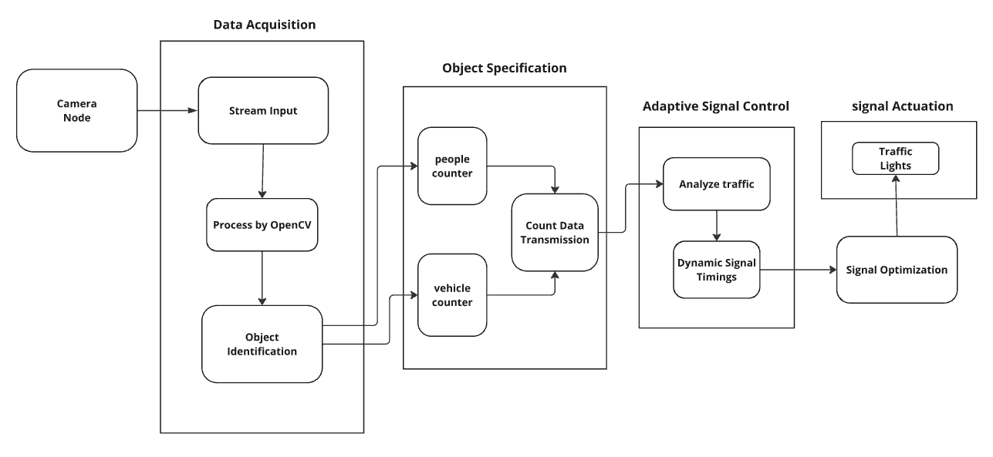

Fig 4.1 Proposed System Architecture

* 1. **UML DIAGRAMS**

# Work Flow Diagram

A workflow diagram is a visual representation of a business process (or workflow), usually done through a flowchart. It uses standardized symbols to describe the exact steps needed to complete a process, as well as pointing out individuals responsible for each step.

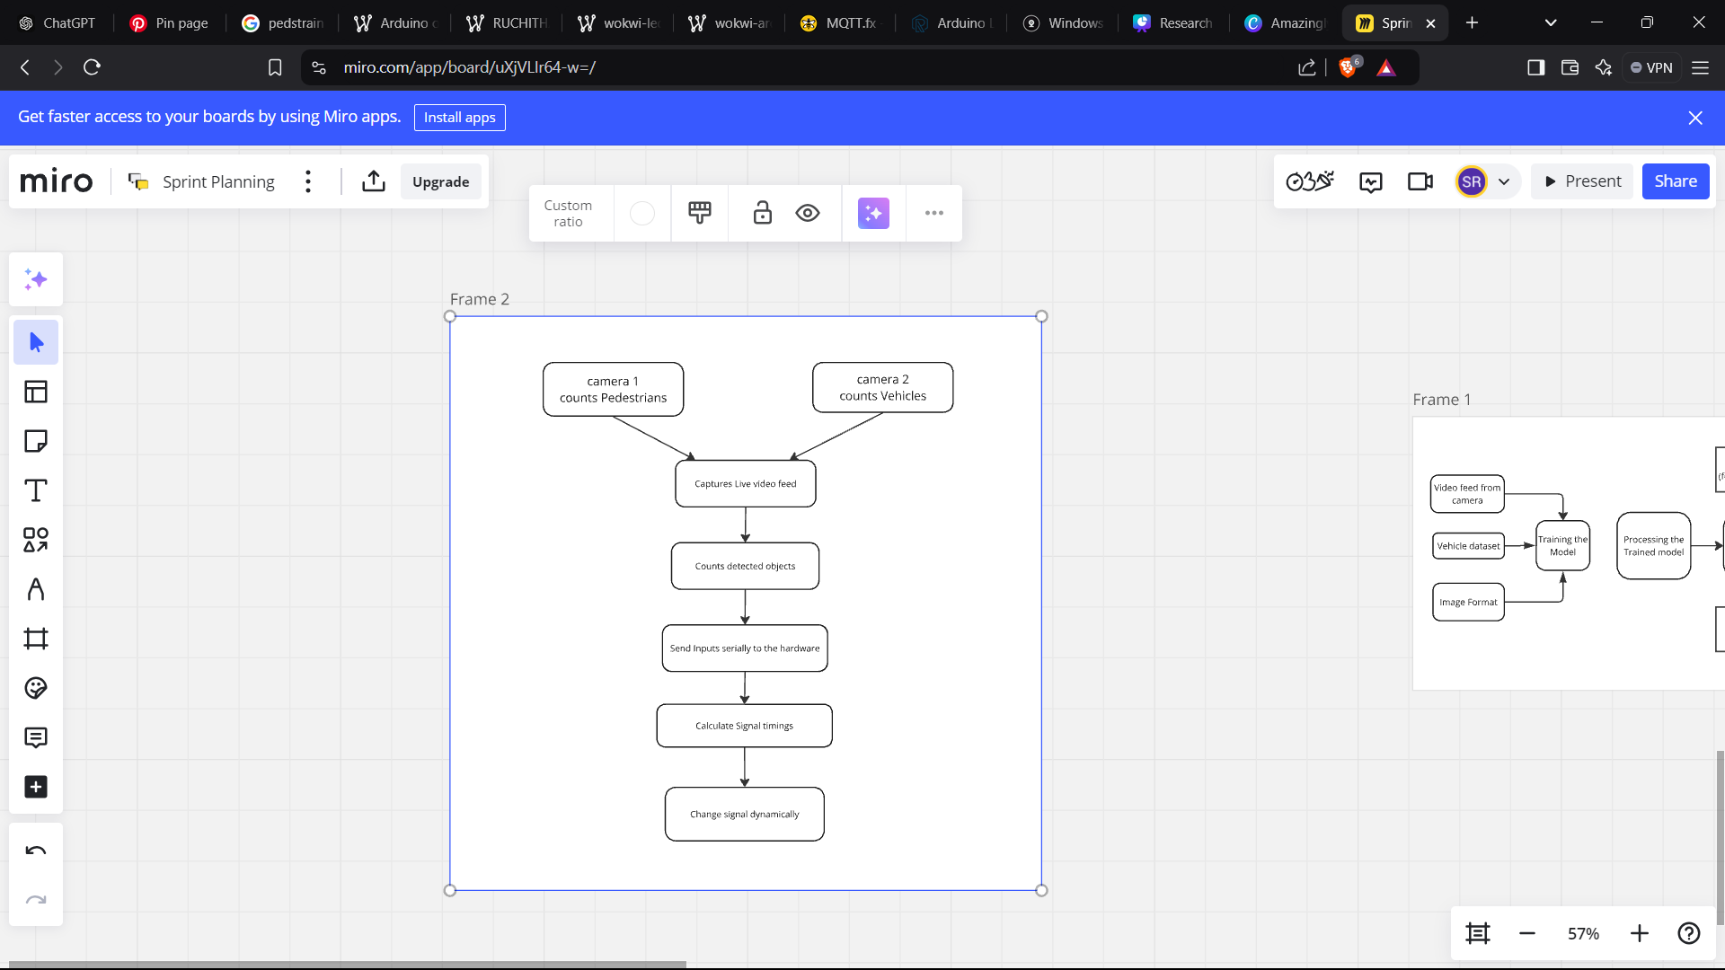

Fig 4.2 Work flow Diagram

# Use Case Diagram

A Use case Diagram is used to present a graphical overview of the functionality provided by a system in terms of actors, their goals and any dependencies between those use cases.

**Use case:** A use case describes a sequence of actions that provided something of measurable value to an actor and is drawn as a horizontal ellipse.

**Actor:** An actor is a person, organization or external system that plays a role in one or more interaction with the system.

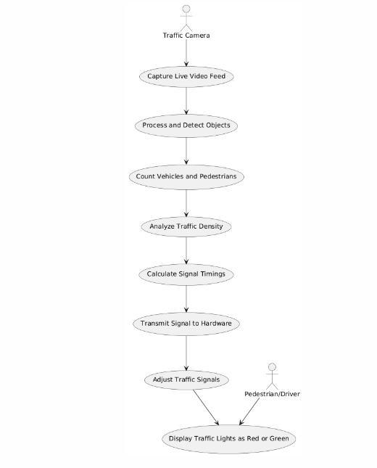

Fig 4.3 Use Case Diagram

# Class Diagram

A class diagram is a graphical representation of a system's static view, showing various aspects of an application. Collectively, these diagrams describe the entire system. Each class diagram should have a meaningful name and clearly identified elements and relationships. Responsibilities (attributes and methods) for each class must be specified, avoiding unnecessary properties to prevent complications. Before finalizing, the diagram should be drawn on paper and revised multiple times for accuracy.

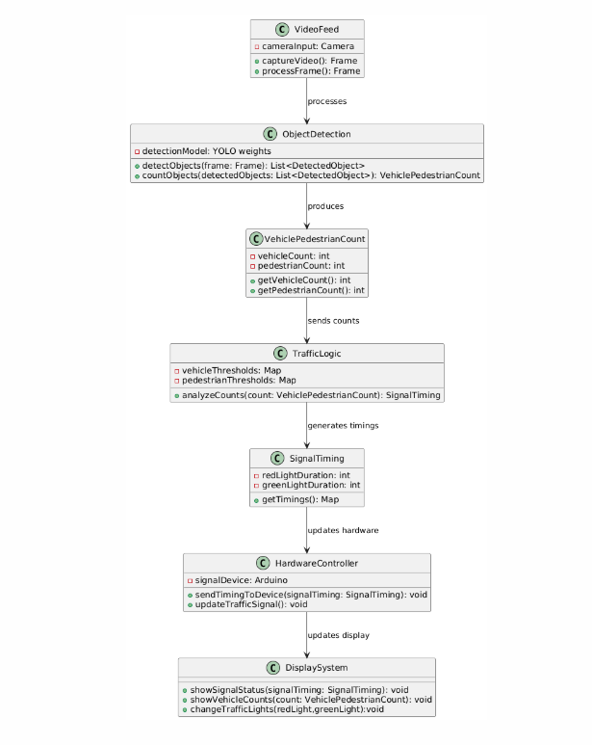

Fig 4.4 Class Diagram

# Activity Diagram

Activity is a particular operation of the system. Activity diagrams are not only used for visualizing dynamic nature of a system but they are also used to construct the executable system by using forward and reverse engineering techniques. The only missing thing in activity diagram is the message part. It does not show any message flow from one activity to another. Although the diagram looks like a flow chart but it is not. It shows different flow like parallel, branched, concurrent and single

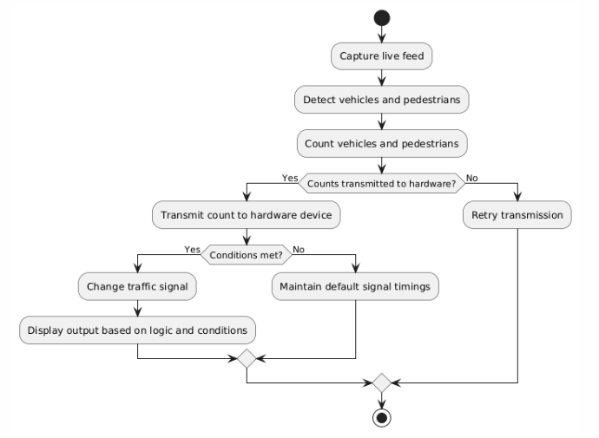

Fig 4.5 Activity Diagram

# Sequence Diagram

Sequence diagrams provide a visual representation of the flow of logic within a system, making it easier to document and validate system behavior. They are widely used during both the analysis and design phases to illustrate how different components interact over time. By focusing on the sequence of messages exchanged between objects or processes, these diagrams help identify and model the dynamic behavior of a system. They are particularly useful in understanding complex workflows and ensuring all system requirements are addressed. As the most popular UML artifact for dynamic modeling, sequence diagrams emphasize the runtime interactions rather than the static structure of a system. This makes them invaluable for designing robust and efficient systems that meet user requirements.

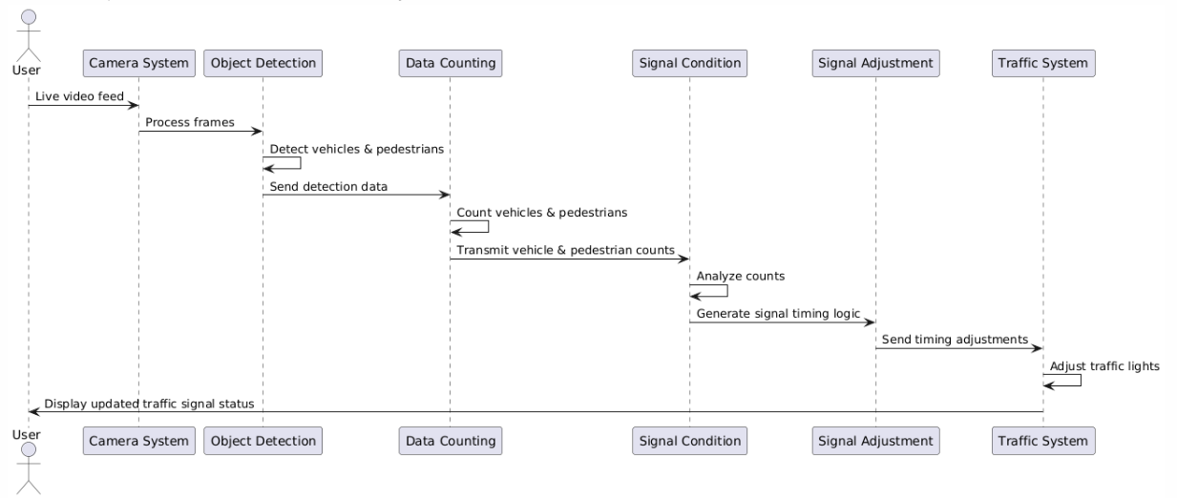

Fig 4.6 Sequence Diagram

**CHAPTER 5**

# IMPLEMENTATION

# 5.1 MODULES

Modules are used primarily to group object definitions together that have a common business purpose or use.

The List of Modules are:

1. Data Acquisition
2. Object Detection
3. Vehicle and Pedestrian Counting
4. Dynamic Signal Adjustment
5. Integration using IoT

# 5.2 MODULE DESCRIPTION

# 5.2.1 Data Acquisition

The purpose of this module is to capture live video feeds from cameras installed at intersections. It includes input devices such as cameras, where one camera monitors vehicle density and the other focuses on pedestrian detection. Tools like OpenCV are utilized for video capture, enabling seamless streaming of video in real-time. The implementation ensures that the frame rate and resolution of the video are optimized to support efficient processing by the YOLO object detection model.

# 5.2.2 Object Detection

This module focuses on the real-time detection of vehicles and pedestrians. Using models, the system identifies various objects within the captured video feed. Essential files, including yolov3.weights, yolov3.cfg, and support this functionality. The implementation involves performing bounding box detection and classification to recognize and differentiate objects such as vehicles and pedestrians

# 5.2.3 Vehicle & Pedestrian Counting

After detecting objects, this module counts the number of vehicles and pedestrians within the video frame. YOLO's output is used to filter specific object classes and count categories like vehicles and pedestrians. These counts are aggregated from detection results and displayed on the interface, with the results stored for further traffic analysis.

# 5.2.4 Dynamic Signal Adjustment

This module dynamically adjusts traffic signal timings based on the detected density of vehicles and pedestrians. It employs logical thresholds for the counts to determine signal adjustments. A pre-trained model, loaded using the joblib library, predicts traffic situations categorized as low, normal, high, or heavy. The traffic conditions are then mapped to appropriate signal timing configurations, ensuring efficient traffic flow management.

# 5.2.5 Integration using IoT

The IoT integration module ensures real-time communication of traffic signal updates to hardware controllers. This involves using devices like Arduino to control traffic signal lights. Protocols such as MQTT or HTTP are employed for communication between the software and hardware. The system sends signal timing adjustments dynamically, facilitating effective traffic management and smoother traffic flows.

**CHAPTER 6**

# TESTING

**6.1 TESTING AND VALIDATION**

To ensure your Dynamic Traffic Management System operates as intended, you need a well-structured testing plan. Below is a comprehensive testing methodology, including types of tests, scenarios, and evaluation metrics

# Unit Testing

Unit testing focuses on verifying the functionality of individual components or modules to ensure they perform as expected. Tools like pytest and unittest, commonly used Python testing frameworks, are employed to carry out these tests.

**Input Collection:** The video feed from both cameras is tested to ensure proper functionality, with checks on frame capture rate and resolution to confirm they meet system requirements.

**Object Detection:** The model's detection accuracy is validated by testing its ability to identify various objects, including vehicles and pedestrians. Confidence thresholds for object detection are also checked to ensure reliability.

**Counts Vehicle and Pedestrian:** Vehicle and pedestrian counts are compared against manually labeled test data to verify accuracy. This step ensures that the system's output aligns with actual observed counts.

**Traffic Signal Timing:** Signal timing outputs are tested against a variety of input scenarios to validate that the system dynamically adjusts signal durations based on traffic condition

# Functional Testing

Functional testing was conducted to ensure proper behavior of the system under various conditions. Key areas of focus included

**Data Acquisition and Object detection:**

Tests are conducted to ensure clear video feeds from both cameras. Validates the accurate detection of vehicles and pedestrians. The system is tested in challenging conditions such as rain, fog, or heavy traffic to maintain detection accuracy.

**Counting of vehicles:**

Ensures the counts of vehicles and pedestrians match manually labeled test data. The system is tested for scenarios involving overlapping objects to ensure precise counting.

**Traffic Signal Timing:**

Checks that signal timings dynamically adjust based on real-time traffic conditions. The module also prioritizes special cases, such as ambulance detection, to ensure emergency responsiveness.

**IoT Integration:**

Tests the real-time communication between the system and hardware. Signal updates are verified to ensure smooth and reliable traffic control, avoiding delays or miscommunication.

**System Scalability:**

Tests are conducted to evaluate the system's ability to handle increased data loads, such as monitoring multiple intersections simultaneously. Ensures that the system maintains performance and detection accuracy without lag or errors when scaled to larger traffic networks.

# 6.1.3 System Testing

System testing ensures that the entire Traffic Management System operates seamlessly and meets the defined requirements. It involves the integration of all modules and testing the system as a whole under real-world conditions.

**End-to-End Workflow Testing**

Verify the complete workflow from video input acquisition to traffic signal adjustment. Ensure proper communication between all modules, including data acquisition, object detection, counting, and signal timing.

**Performance Testing**

Assess system performance under varying traffic densities, such as peak hours and low-traffic conditions. Test the system’s ability to process video feeds and provide real-time signal adjustments without delays.

**Integration Testing**

Verify the smooth interaction between software modules Ensure IoT modules correctly transmit signal timing instructions.

**Stress Testing**

Test the system’s reliability by simulating high-traffic scenarios with simultaneous pedestrian and vehicle detection. Ensure no system crashes or performance degradation under heavy workloads.

**System Responsiveness**

Confirm the system adapts dynamically to changes in traffic conditions within the expected response time. Validate real-time adjustments to traffic lights and immediate prioritization of emergency scenarios.

# 6.1.4 Acceptance Testing

Acceptance testing ensures that the Traffic Management System meets user requirements, aligns with project goals, and performs effectively in real-world scenarios. It focuses on validating the system's functionality, usability, and performance to gain final user approval.

**Real-World Video Input Testing**

Validate the system's ability to process live video feeds from CCTV cameras positioned at intersections. Ensure the video feed quality is sufficient for accurate detection and analysis of vehicles and pedestrians.

**Vehicle and Pedestrian Detection**

Confirm that the system detects all relevant objects, such as cars, bikes, buses, trucks, and pedestrians, with high accuracy. Verify that object counts match manual observations and are displayed correctly.

**Dynamic Signal Adjustment**

Test whether the system dynamically adjusts traffic light timings based on real-time traffic conditions. Ensure that the adjustments reduce congestion and prioritize safety, especially in scenarios with high pedestrian density or emergency vehicles.

**Performance Under Stress**

Simulate heavy traffic or high pedestrian density scenarios to evaluate the system's performance under peak load. Ensure the system operates without lag or failure and maintains real-time processing.

**IoT Integration Validation**

Test the communication between the software and hardware components (traffic light controllers) to ensure accurate implementation of signal changes.

# 6.2 BUILD THE TEST PLAN

For your Traffic Management System project, the testing will be divided into unit tests, functional tests, and system-level tests across the various components of the system. Each feature will be validated in isolation before conducting integration tests. Specific test plans will be developed for:

**Vehicle Detection and Counting**

Verifying that the vehicles are detected accurately in real-time video feeds, ensuring that the counting system updates correctly without missing or double-counting vehicles.

**Pedestrian Detection and Counting**

Ensuring pedestrians are detected accurately in video streams, with the correct count being maintained across various conditions (e.g., heavy foot traffic, walking speed).

**Traffic Signal Timing Adjustment**

Confirming that traffic signal timings are dynamically adjusted based on vehicle and pedestrian counts, validating that the correct signal changes are triggered based on predefined thresholds.

**Integration of IoT with Traffic Signals**

Ensuring seamless communication between the software system and IoT hardware (Arduino), verifying that traffic signal timings are sent and applied correctly to the traffic signal lights.

**System Compatibility and Performance**

Testing the overall system for compatibility with different video input sources, ensuring real-time processing of video data without significant delay or lag, and confirming that the system performs under various traffic conditions.

**Edge Case Handling and Error Recovery**

Verifying the system's ability to handle edge cases, such as malfunctioning cameras, unexpected traffic scenarios (e.g., accidents), and ensuring graceful error recovery and system stability.

**Environmental Condition Adaptation**

Testing the system under varying environmental conditions, such as low light, rain, fog, and glare, to ensure the accuracy of detection and proper functioning of signal timing adjustments without performance degradation.

Table 6.1 Test Case Design

|  |  |  |  |  |  |
| --- | --- | --- | --- | --- | --- |
| **S. No** | **Test Case ID** | **Test Description** | **Test Input** | **Expected Result** | **Actual**  **Output** |
| 1 | TC01 | Verify system captures video frames in real time | Connect to camera and produce  Live video feed | Video frames are captured and processed at the required frame rate. | PASS |
| 2 | TC02 | detects all objects accurately  by trained model. | Test image or video with vehicles pedestrians, etc. | Objects are detected and classified with confidence scores above the set threshold. | PASS |
| 3 | TC03 | Validate vehicle & people counts | Video frame with a known count of vehicles and pedestrians | System output matches the manually counted objects. | PASS |
| 4 | TC04 | Verify traffic signal timing adjustments | i.e.,  Vehicle count = 14  Pedestrian count = 3 | Signal timing adjusts dynamically,  e.g.,  Green: 90s,  Red: 30s. | PASS |
| 5 | TC05 | Signal changes dynamically | Continuous  Vehicle counts | Serially receives input and changes the signal | PASS |

Table 6.2 Test Case Log

|  |  |  |  |
| --- | --- | --- | --- |
| **S. No** | **Test ID** | **Test Description** | **Test Status (Pass/Fail)** |
| 1 | TC01 | Verify system captures video frames in real time | PASS |
| 2 | TC02 | Verify detects objects accurately with the loaded model | PASS |
| 3 | TC03 | Validate vehicle and pedestrian counts simultaneously | PASS |
| 4 | TC04 | Validate latency between input and feeds logic related to vehicle counts | PASS |
| 5 | TC05 | Validate communication with hardware by change in signal | PASS |

# CHAPTER 7

# RESULTS AND DISCUSSION

In the previous traffic management systems (Fig 7.1) demonstrated limited improvements in urban mobility. Static signal timings resulted in a 20% reduction in vehicle wait time and a modest 10% decrease in jaywalking incidents. Pedestrian safety measures contributed to an 8% reduction in pedestrian-related accidents. However, the systems were less effective in optimizing environmental impacts, with only a 5% reduction in fuel consumption. Implementation cost savings were moderate, at 25%, as traditional traffic systems relied heavily on physical sensors. Despite these efforts, the community's perceived improvement was only 50%, highlighting the need for more adaptive solution

This Dynamic Traffic Management System (Fig 7.2) significantly outperformed its predecessor. Real-time traffic signal adjustments reduced vehicle wait times by 35%, addressing peak-hour congestion effectively. Pedestrian monitoring improved safety, leading to a 20% reduction in jaywalking incidents and a 15% decrease in pedestrian-related accidents. Environmental benefits were notable, with a 10% decrease in fuel consumption and associated emissions due to reduced vehicle idle times. Implementation cost savings increased to 40%, as the system relied on scalable, video-based solutions instead of physical sensors. Community feedback was overwhelmingly positive, with 85% of users perceiving improved traffic conditions and safety. Businesses near intersections also reported increased foot traffic, further highlighting the system’s overall efficiency and impact.

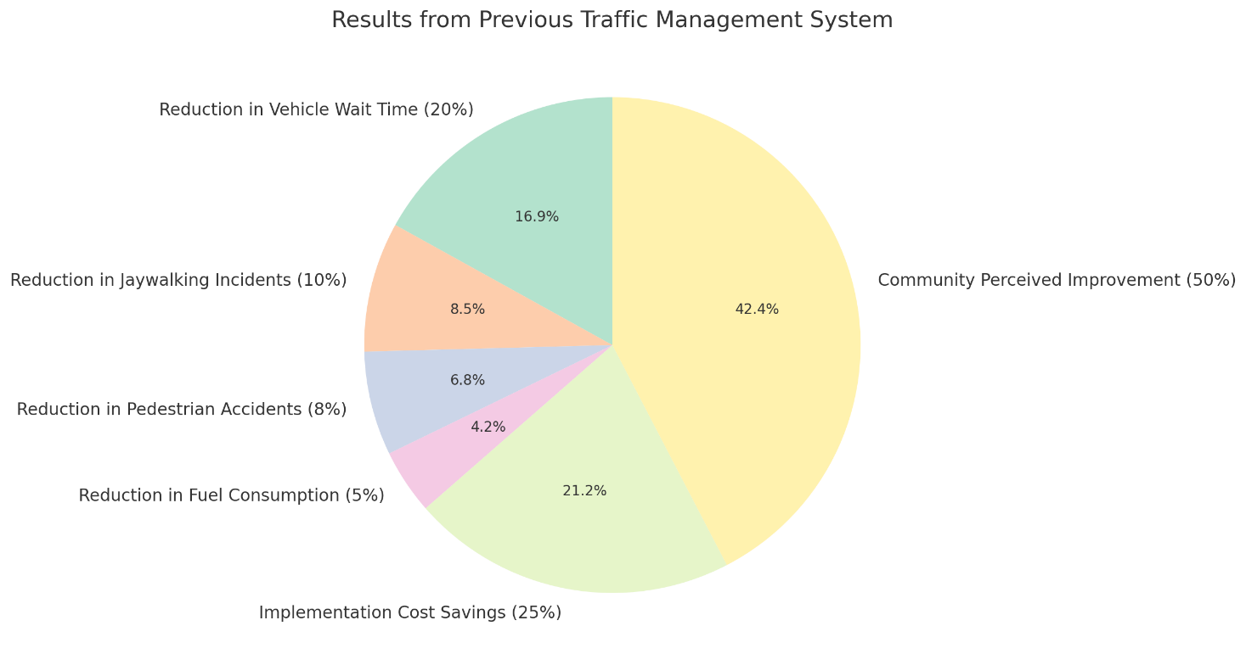

Fig 7.1 Analysis of previous Traffic Systems

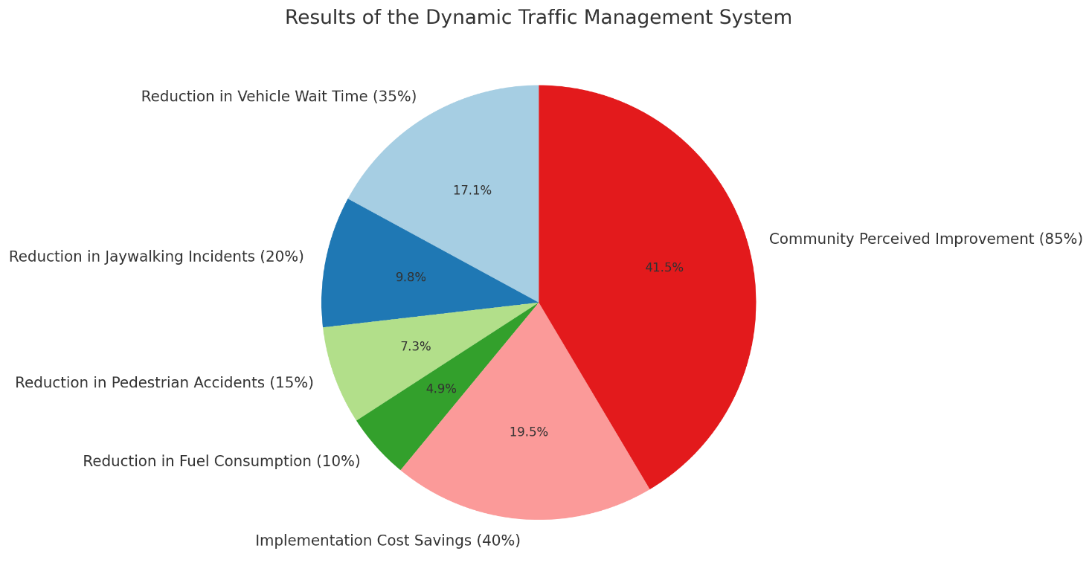

Fig 7.2 Results of this Dynamic Traffic System

**Discussion**

The dual-camera setup of the system efficiently monitored both vehicle and pedestrian activities, providing comprehensive traffic analysis. Machine learning integration demonstrated high accuracy in predicting traffic situations, enabling proactive signal adjustments. However, challenges such as degraded video quality under extreme weather conditions occasionally impacted performance. IoT integration and predictive algorithms addressed many of these issues, although initial deployment required substantial training of machine learning models, which demanded significant computational resources.

Scalability remains a strength of the system due to the absence of physical sensors, although stable internet connectivity is necessary for seamless operation. Future improvements include enhanced video processing algorithms and better low-light optimization to increase reliability. Integrating external data sources, such as public transit schedules or emergency alerts, could further optimize traffic management. Exploring alternative power solutions, like solar energy, would also enhance sustainability.

The broader implications of this system include potential widespread reductions in urban congestion, contributing to more livable cities. Environmental benefits, such as lower emissions and reduced fuel consumption, align with global sustainability goals. The results underscore the system’s potential to revolutionize urban mobility by addressing critical challenges in traffic flow, safety, and environmental impact.

**CHAPTER 8**

# USER MANUAL

**Step 1: Installing Prerequisites**

Before setting up the Dynamic Traffic Management System, ensure the following requirements are met:

* Dual-camera setup for monitoring vehicle density and pedestrian crossings.
* A processing unit with sufficient computational capacity for machine learning models.
* Stable power supply for all components.
* Pre-trained or customizable machine learning models for traffic analysis.
* IoT devices integrated into the system.

**Step 2: Setting Up**

* Mount the cameras at intersections with clear visibility.
* Connect the cameras to the processing unit.
* Establish a network connection using Ethernet cables or wireless modules.
* Calibrate the cameras to define zones for detecting vehicles and pedestrians.
* Upload or train machine learning models to predict traffic patterns.
* Link IoT devices (if used) to gather supplementary data.

**Step 3: Process and Implementation**

* The cameras capture real-time video feeds for vehicles and pedestrians.
* Data is processed by the machine learning models to analyze traffic density and predict patterns.
* The Traffic Management Application adjusts signal timings dynamically based on the logics provided to enumerate the lightings.
* Priority is assigned to pedestrians or vehicles as per predefined rules and real-time conditions.

**Step 4: Running the System**

* Connect cameras for live video feed or use pre-recorded video files for testing.
* Execute the object detection script to identify vehicles and pedestrians.
* Check for bounding box accuracy and confirm real-time detection output.
* Use the pre-trained machine learning model to analyze vehicle and pedestrian counts.
* Dynamically adjust traffic signal timings based on detected traffic density and pre-defined conditions.
* Display detected objects, counts, and updated signal timings on the system interface.

**CHAPTER 9**

# CONCLUSION

The dynamic traffic management system developed in this project effectively addresses urban traffic congestion by leveraging real-time data from video feeds to adjust signal timings based on both vehicle and pedestrian counts. This system prioritizes pedestrian safety during crowded conditions and ensures smooth vehicle flow during high traffic periods. Its adaptability to varying traffic conditions allows for efficient management of intersections, reducing delays and improving overall traffic flow. The system is scalable, cost-effective, and environmentally friendly, as it reduces fuel consumption and emissions. However, its reliance on accurate detection through video feeds suggests a need for further improvement, such as integrating additional sensors. Overall, this project presents a smart and sustainable solution for modern traffic management, offering potential enhancements like predictive traffic flow adjustments and emergency vehicle prioritization for further optimization.

**CHAPTER 10**

# FUTURE ENHANCEMENTS

While the Dynamic Traffic Management System addresses many modern urban traffic challenges, some drawbacks include dependency on video quality, which can be affected by adverse weather or low-light conditions, high computational requirements that may increase costs, reliance on stable internet connectivity that limits deployment in areas with poor network infrastructure, and limited integration with other urban systems such as public transport and emergency response networks. Future enhancements should focus on advanced video processing algorithms to improve performance in challenging conditions, implementing edge computing to reduce latency and internet dependency, incorporating renewable energy solutions like solar power for sustainability, and enabling comprehensive data integration with public transit and emergency services. Further upgrades could include self-learning machine learning models for dynamic adaptation, user-friendly interface improvements for better system management, and enhanced scalability to support larger urban networks effectively.

**APPENDIX I**

**BASE PAPER**

**APPENDIX II**

**SCREEENSHOTS**

**Camera 1: Detection of vehicles on road**

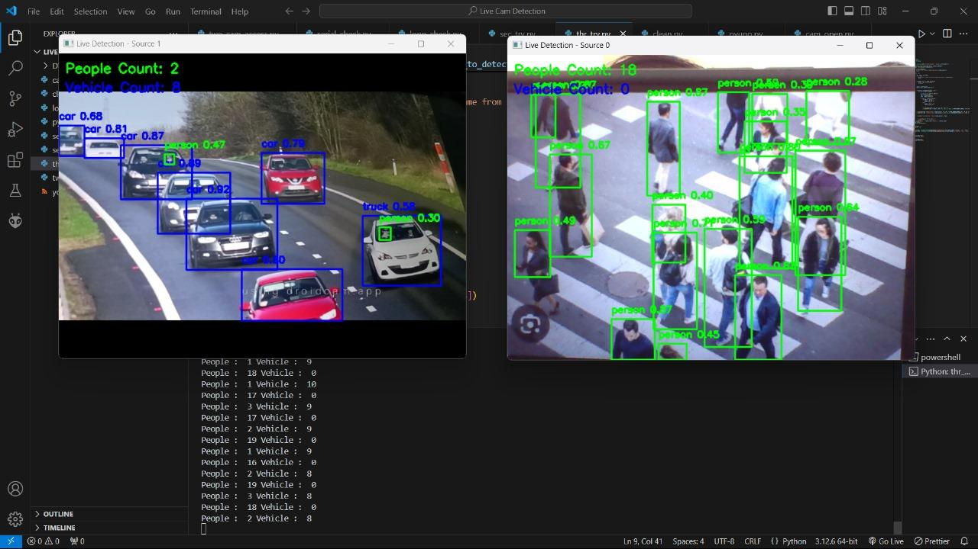

**Camera 2: Detection of People on pedestrian crossing**



**Signal Lights changes to Red**

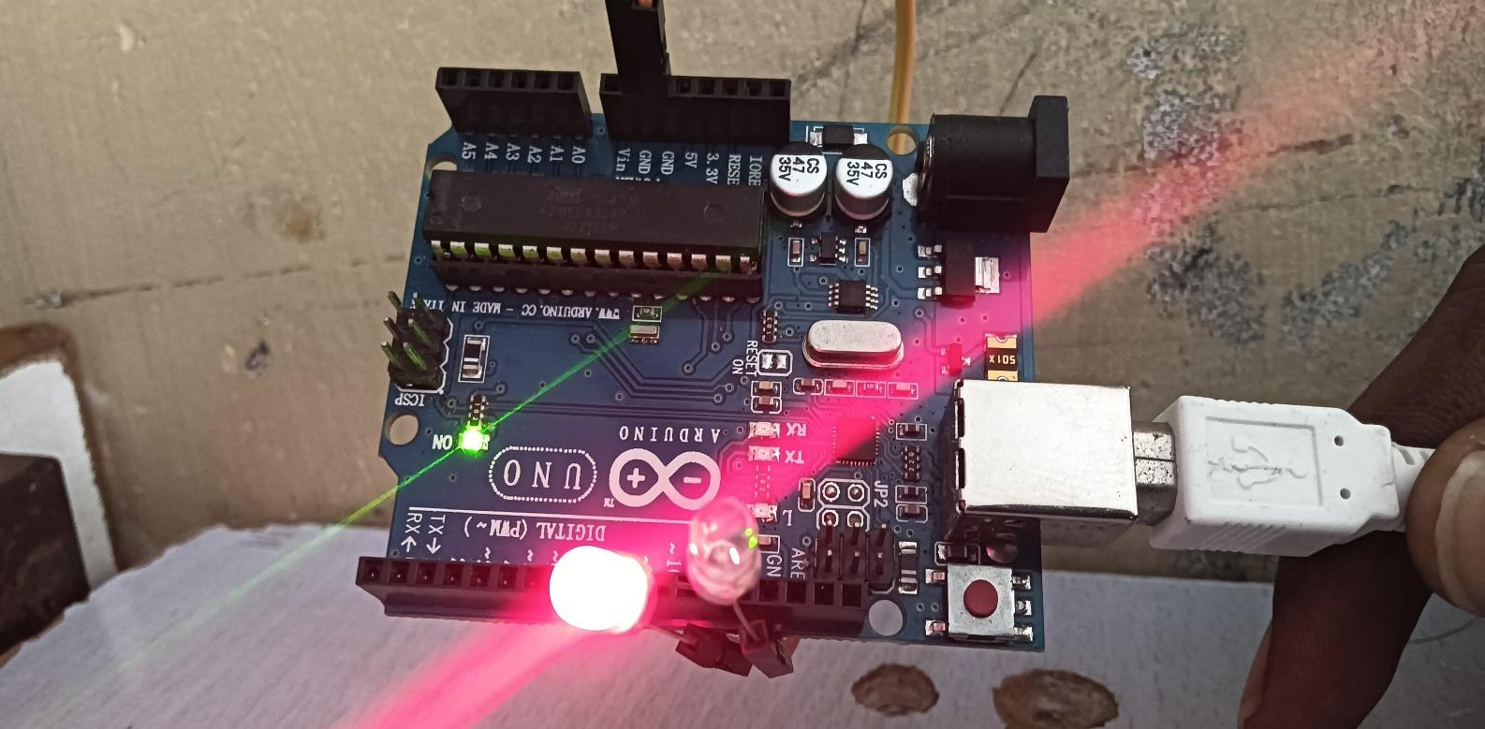

**Signal Lights changes to Green**

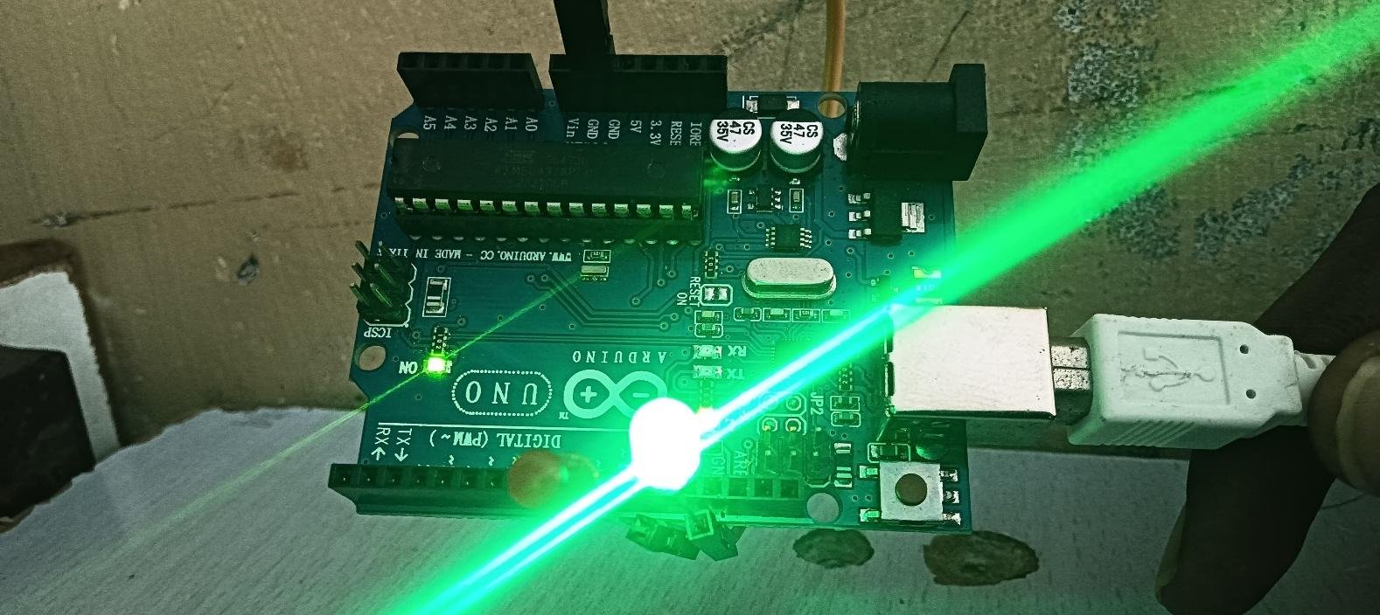

**APPENDIX III**

**INTERNSHIP CERTIFICATES**





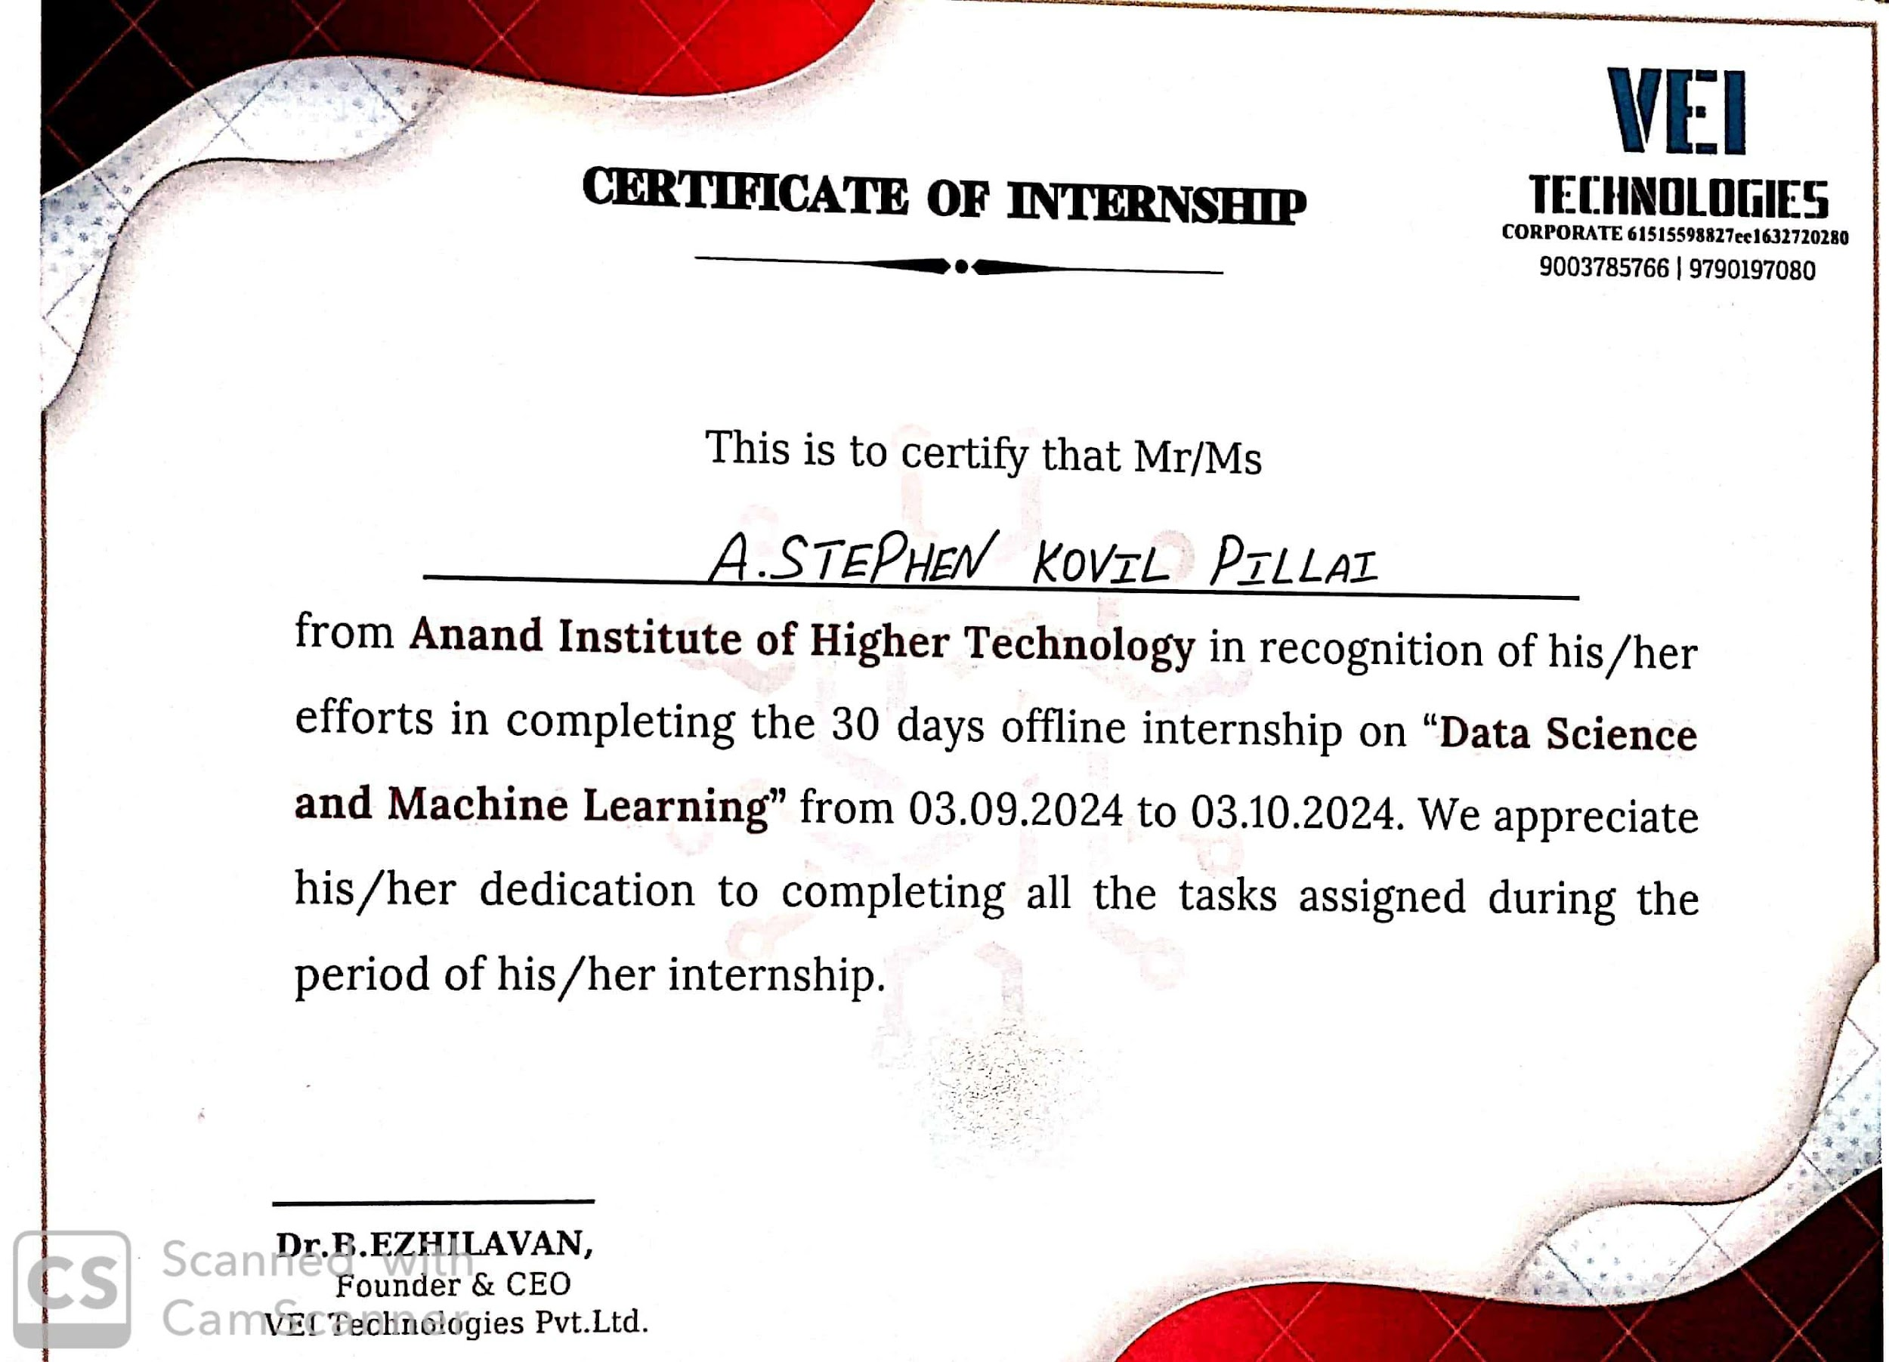

# REFERENCES

* 1. Al-Smadi, M., Abdulrahim, K., & Salam, R. A. Review of vision-based vehicle identification, recognition, and tracking for traffic surveillance.
  2. Zhao, Z. Q., Zheng, P., Xu, S. T., & Wu, X. (2019). Object identification using deep learning: A review.
  3. Han, D., Leotta, M. J., Cooper, D. B., & Mundy, J. L. (2006). Recognition of vehicle classes from videos using 3D curve probes. In Proceedings of the International IEEE Workshop on Visual Surveillance and Performance Evaluation of Tracking and Surveillance.
  4. Qiu-Lin, L. I., Jia-Feng, H. E., & Co. Vehicle detection using the cross-entropy threshold approach and the three-frame difference method. Computer Engineering, 172–174.
  5. Liu, Y., Yao, L., Shi, Q., & Ding. (2014). Tracking vehicles on urban roads using optical flow. In Proceedings of the 9th International Conference on Computational Intelligence and Security (2013).
  6. Girshick, R., Donahue, J., Darrell, T., & Malik, J. (2014). Rich feature hierarchies for accurate object detection and semantic segmentation. In Proceedings of the IEEE Conference on Computer Vision and Pattern Recognition (CVPR).
  7. Park, K., Lee, D., & Park, Y. (2005). Video-based detection of illegal street parking violations. In Proceedings of the International Image Processing Conference.